Self-Image & Goal Setting
Self-image:
How is it formed?
What effects it?
Can we change it?
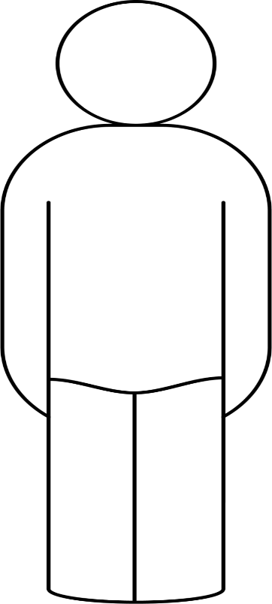
1.
2.
3

